**Northeastern University, Silicon Valley**

**INFO 5100**

**Application Engineering and Development**

**Read Me Document**

**Final Project: Image management Tool**

Instructor:

Taral Oza

[taral.educator@gmail.com](mailto:taral.educator@gmail.com)

Teaching Assistant:

Lumi Chu

[chu.dan@husky.neu.edu](mailto:chu.dan@husky.neu.edu)

Project Team Members:

Huixiang Liu [liu.huix@husky.neu.edu](mailto:liu.huix@husky.neu.edu)

Soumya Murugendrappa

murugendrappa.s@husky.neu.edu

Introduction:

Image Management Tool is a GUI that facilitates user to upload images and to download the uploaded images in the desired format. The tool is designed in a way which helps user to upload one or more images. Once uploaded, all the images are shown as thumbnails (100*100). Also, when mouse is hovered on an image on thumbnail, image’s properties are shown to user. The user can select desired image format to download all the images or can check zip option to download all images in the original format in a zipped folder. The tool is designed to support image formats like JPG, PNG, GIF, BMP and WebP. The project is enhanced to include a functionality of image filters where a single image is uploaded by user to get 3 filtered views (greyscale, high contrast and low contrast)

Basic Components for project development:

1. Used JavaFX for GUI development
2. Demonstrated the use of inheritance, encapsulation and interfaces
3. Download logic of the code uses one design pattern (Factory design pattern)
4. Code is well commented
5. Appropriate exception handling.

Steps to work with the Tool:

1. Extract the below zip file and import it into IntelliJ



1. Once the project is succesfully imported into IntelliJ, click on run to run the project.
2. Once project is run, you will see below window that has two buttons “Upload Images” and “Image filters”.

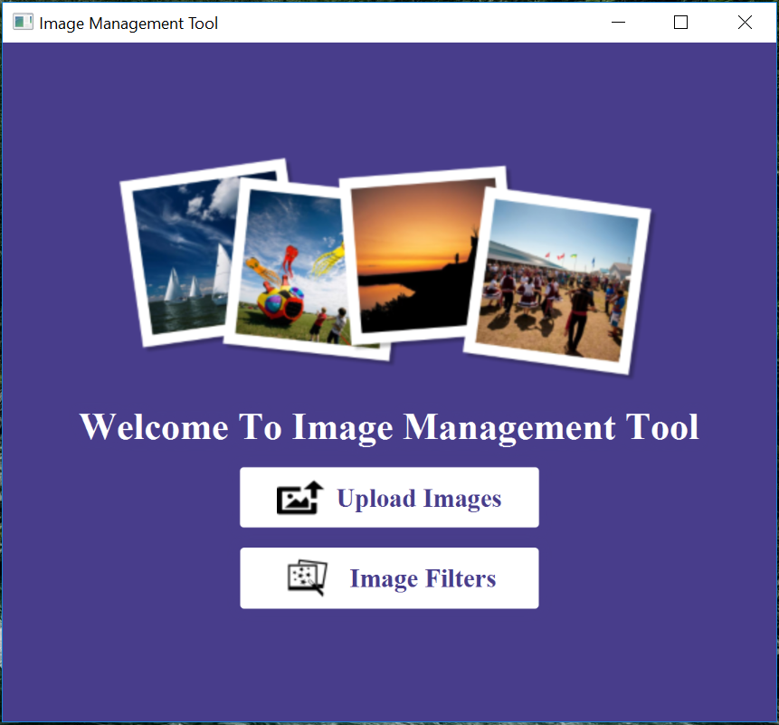

1. Click on “Upload Images” button. Below window appears which allow user to select one or more images as shown.

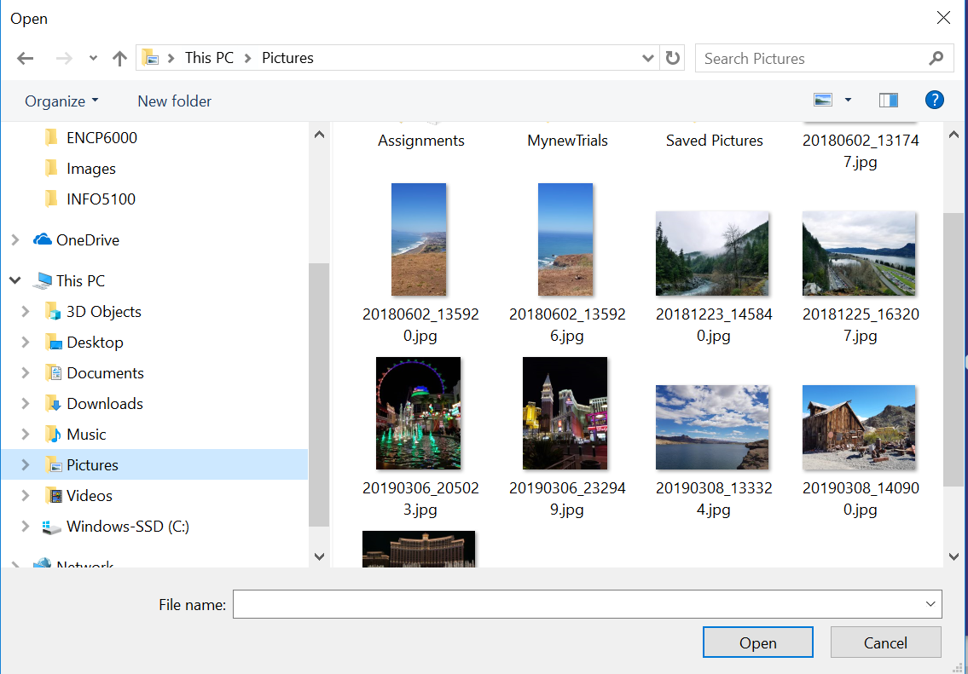 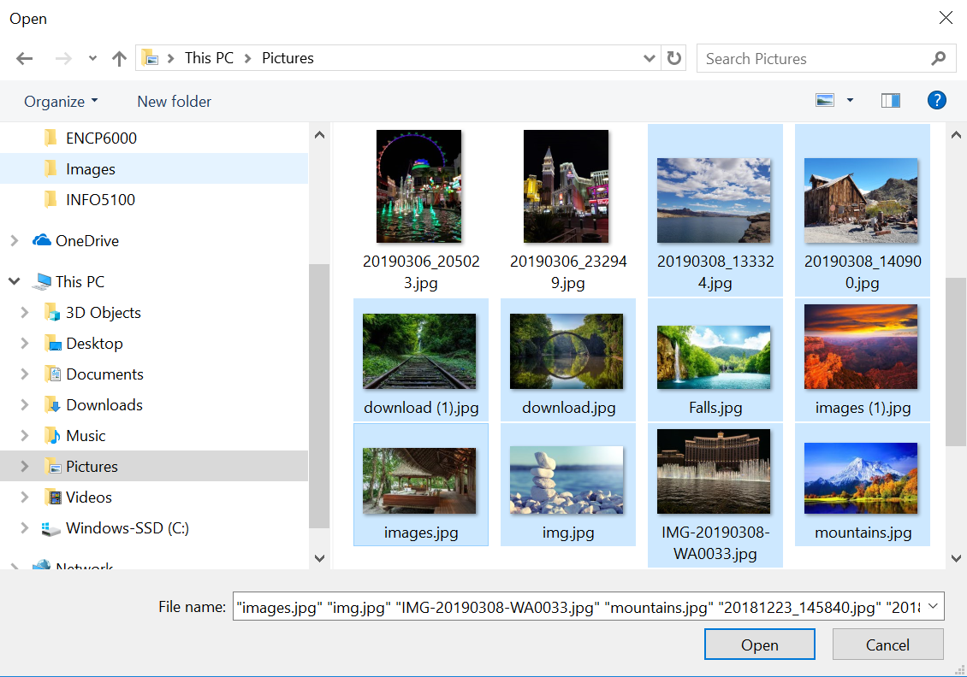

**After selecting images**

**Before selecting images**

